DBMS Assignment Lab 10

Tarun M

PES1UG20CS462

1) Screenshot of database with the table – ‘train’ before populating it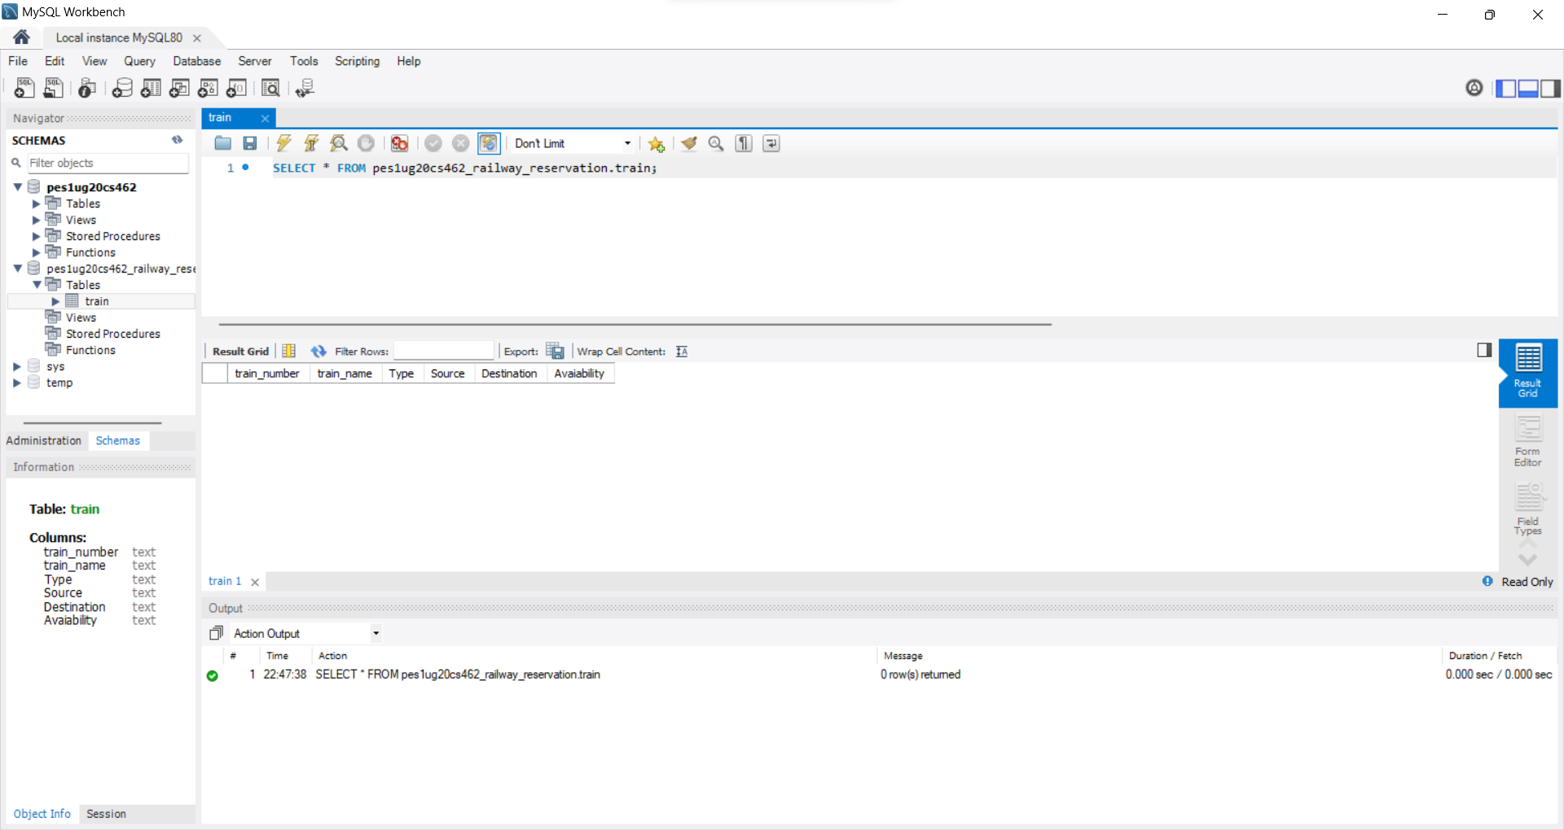

2) Screenshot of the User Interface

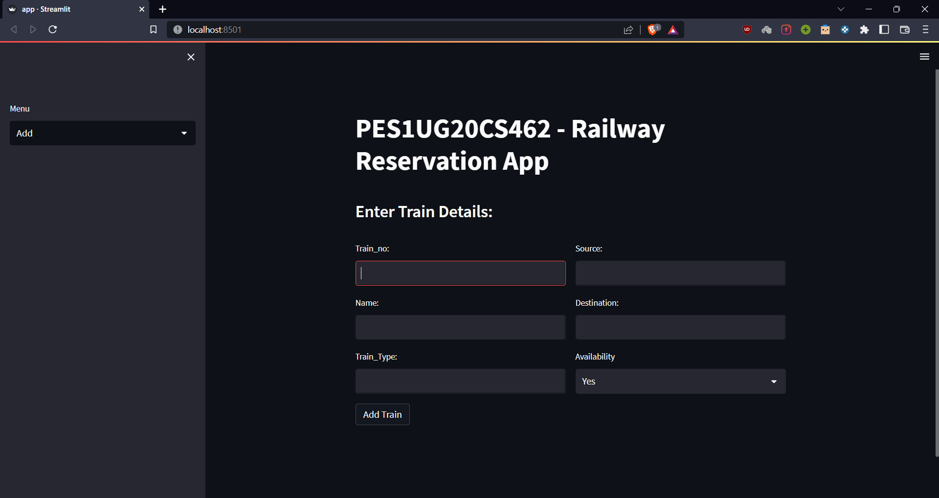

3) Screenshot of the 3 records in the train table from MySQL WorkBench

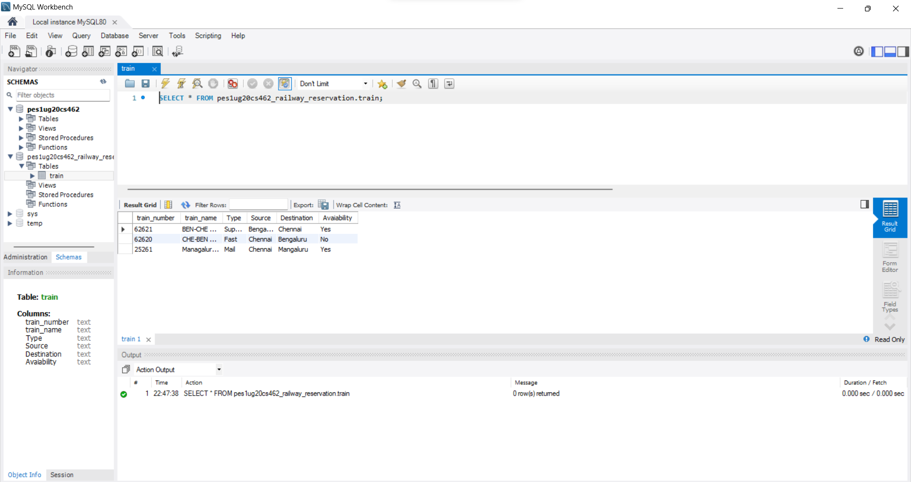

4) Screenshot of the same 3 records visualised in the User Interface

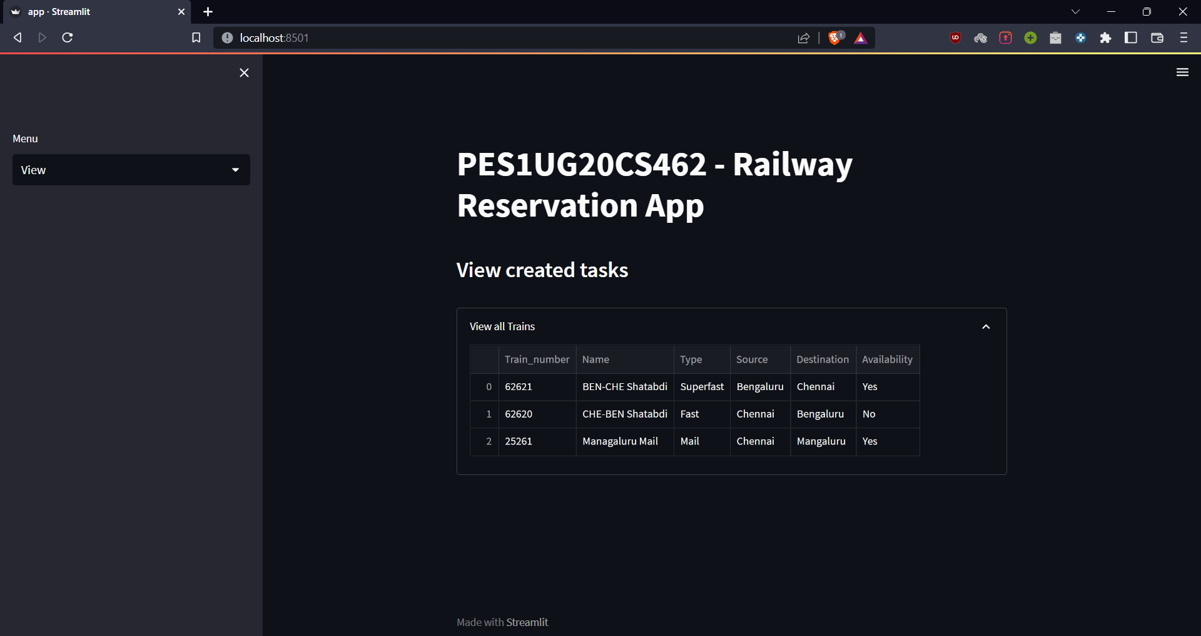

5) Screenshot of Updated Train_No 62620 in the User-Interface

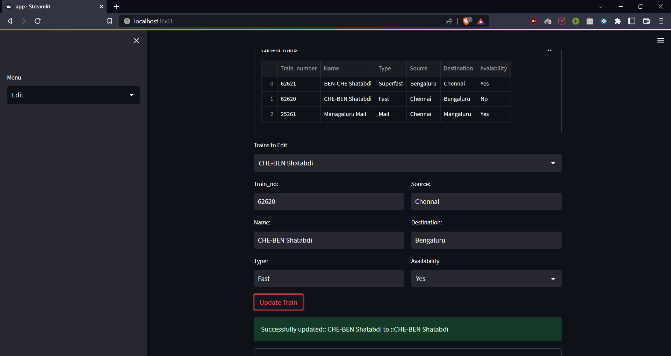

6) Screenshot of User-Interface after the Train_No 25261 has been deleted

